CompTIA A+ project
● Create a user using the command below
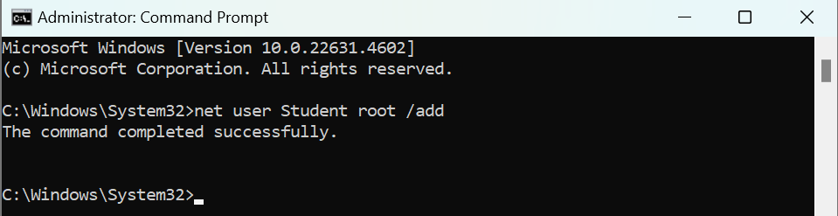○ net user username password /add
● Check to see if the user has been added
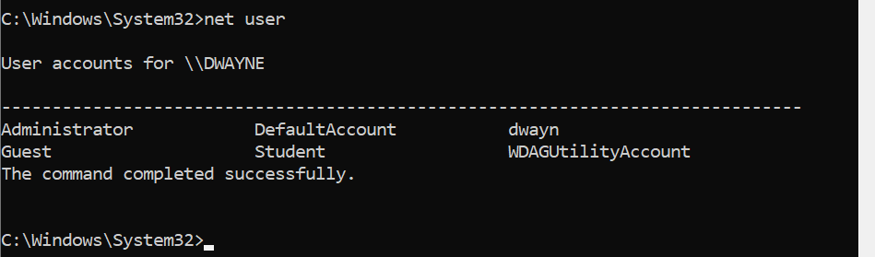

○ net user
● Check your created user’s details/settings
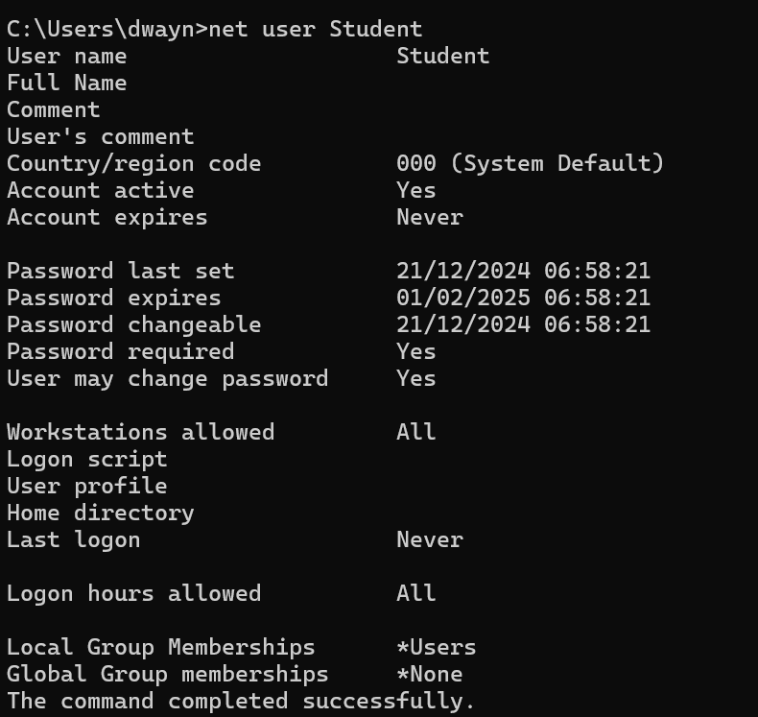
○ net user username
● Check addresses
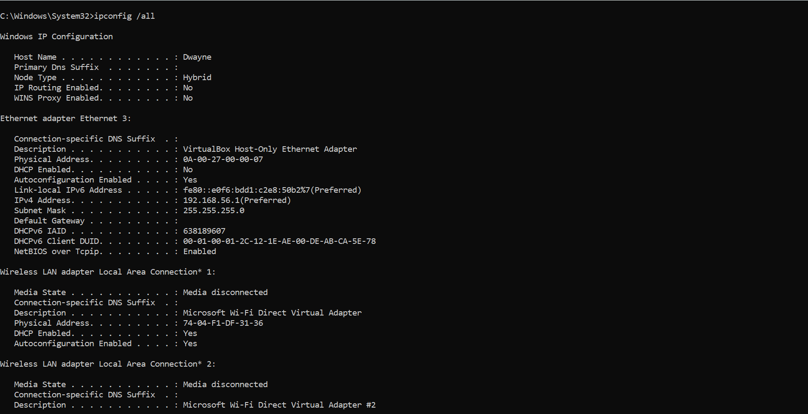

○ ipconfig /all
● Ping your IP address
○ ping ipaddress
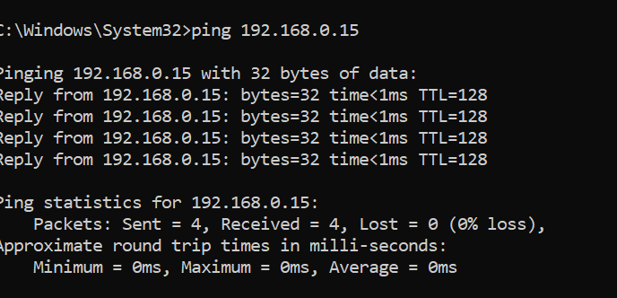
● Create a folder and name it CompTIA A+ project, give the user you have just created read rights
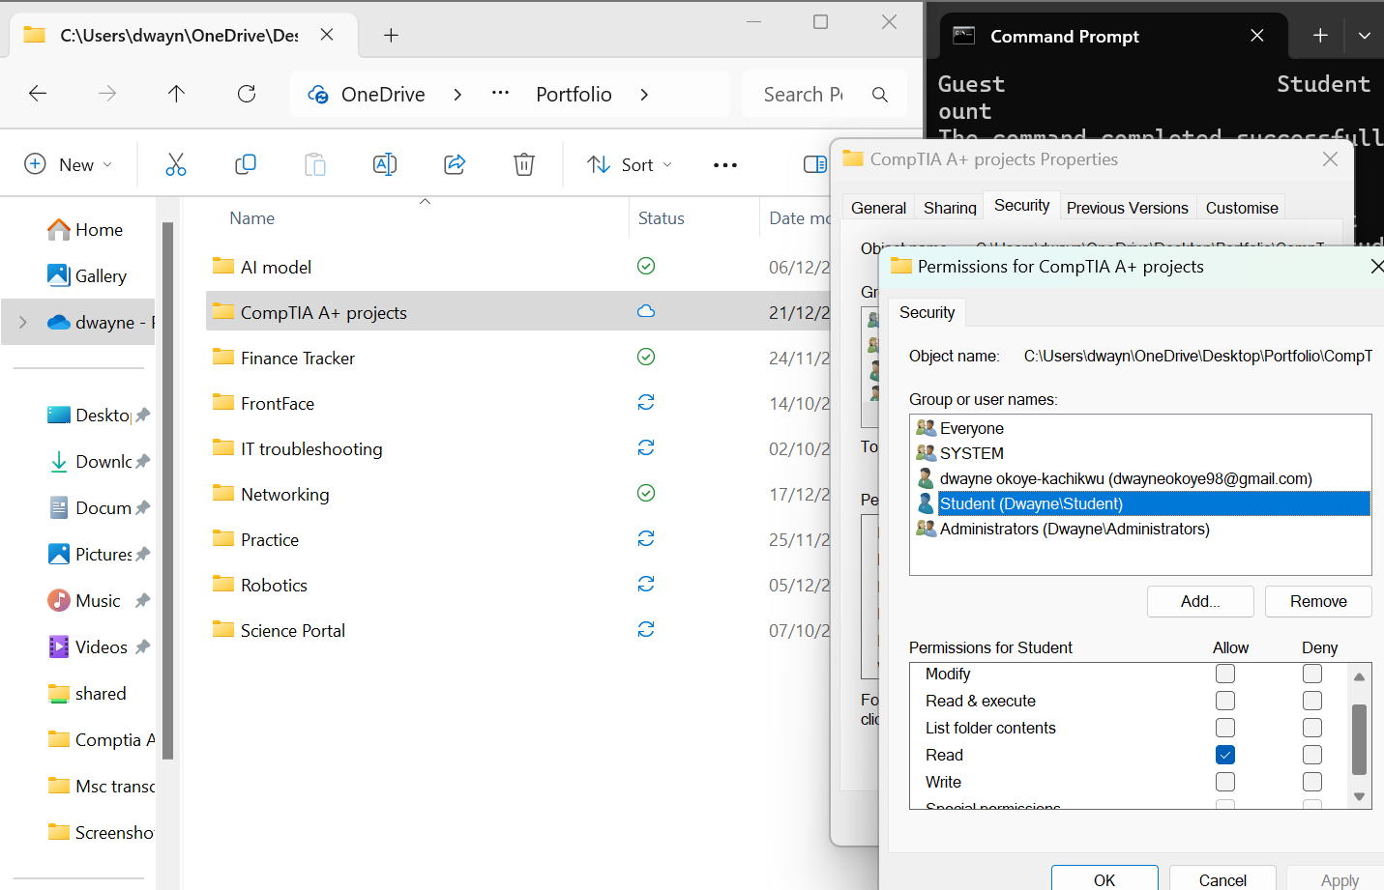

to the CompTIA A+ project folder
● Check computer specs
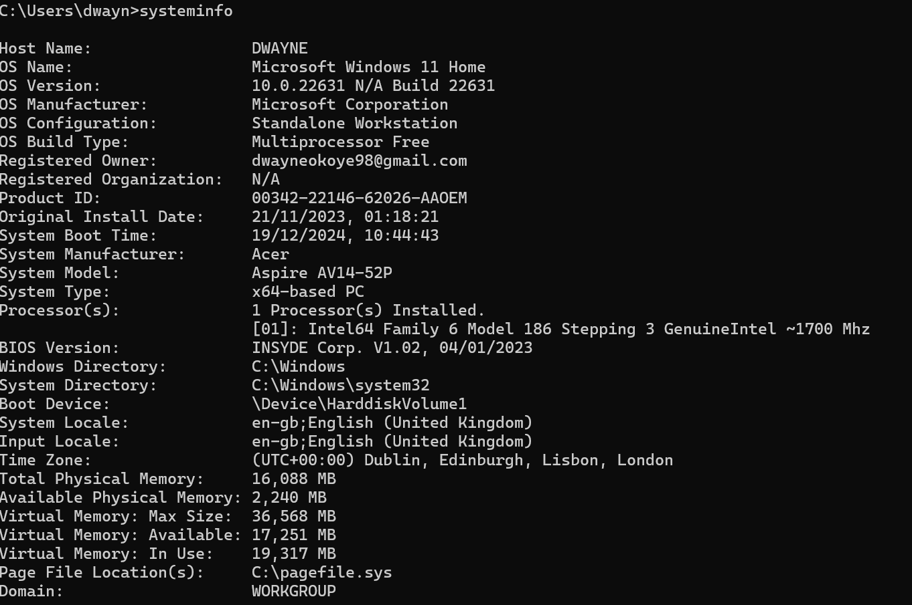
● Use control panel to show how you would uninstall an application (you do not need to uninstall
any of your programs)
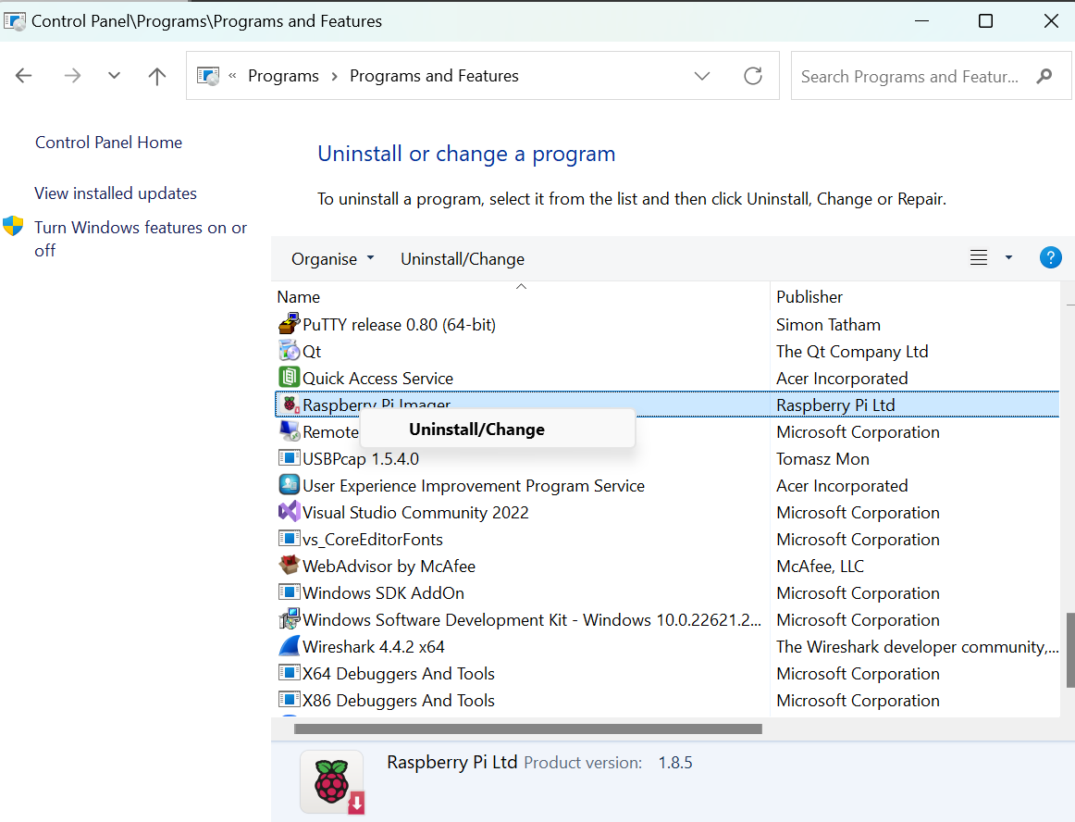

● Check your wifi properties using network and internet settings
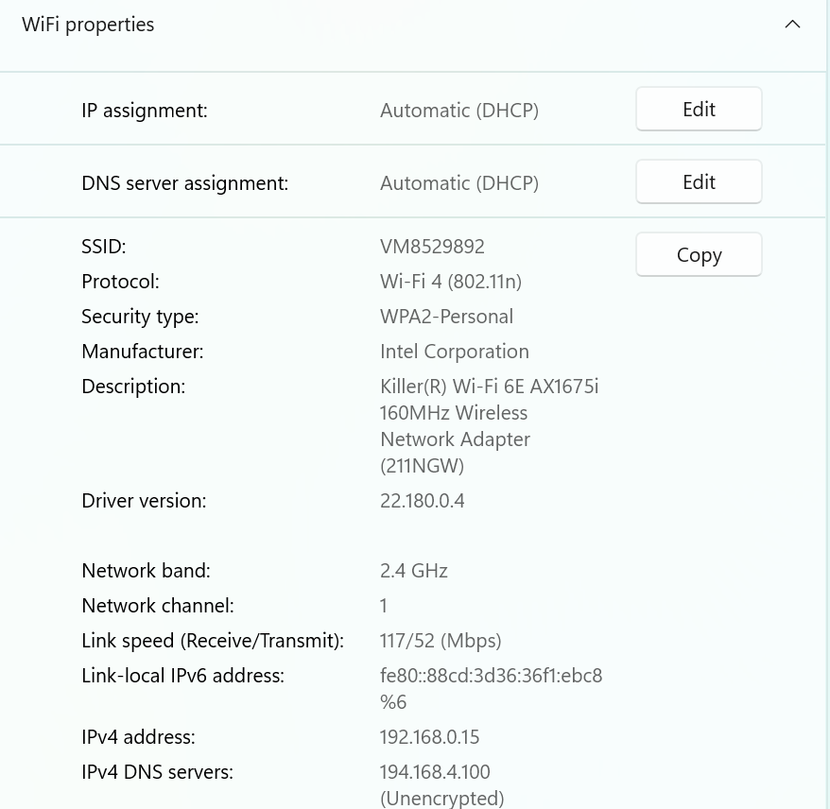

● Check CPU, memory,DISK and network usage using task manager
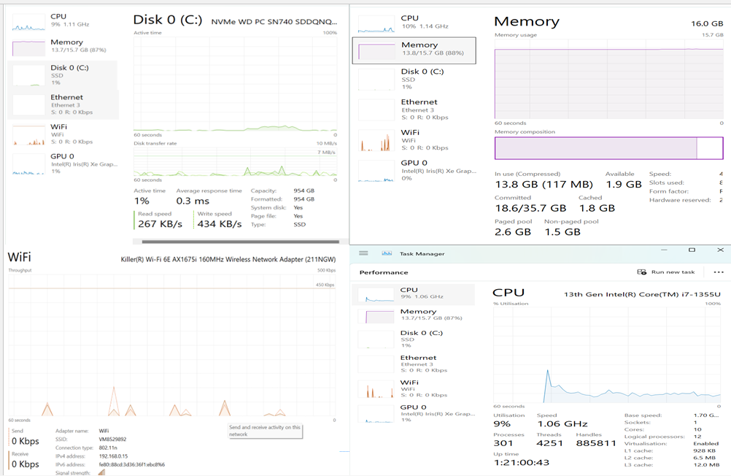
● Check System restore options for backup
